- From home page at http://www.riveroflifems.com Click on “Donate”
  - 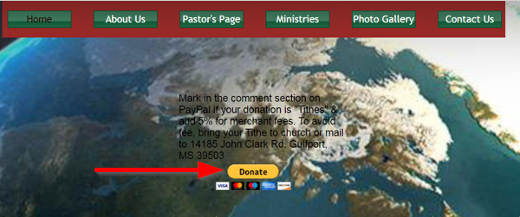
- Enter $ amount and choose to “Donate with PayPal” or “Donate with a Debit or Credit Card” (Check the square next to “Make this a monthly donation” should you wish)
  - 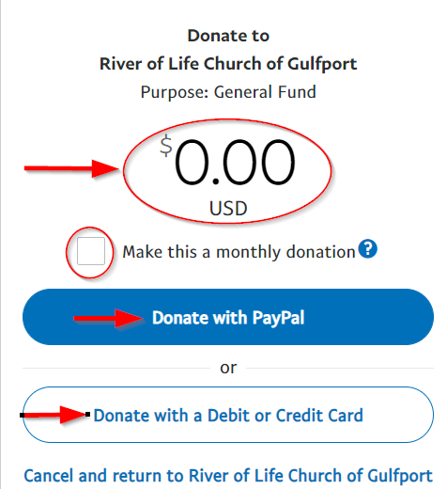
    - Donate with PayPal
      - Login into your PayPal account or “Create Account”
        - 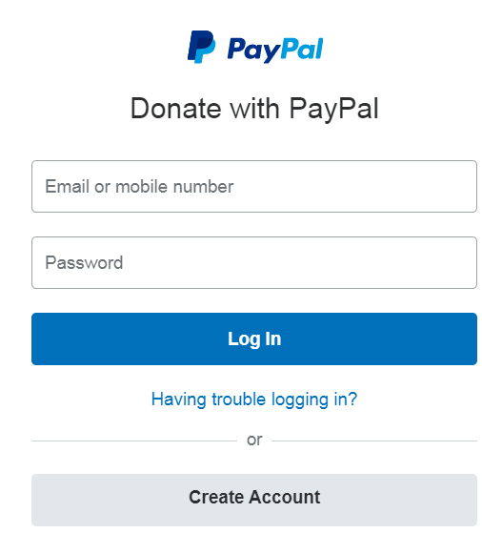
        - 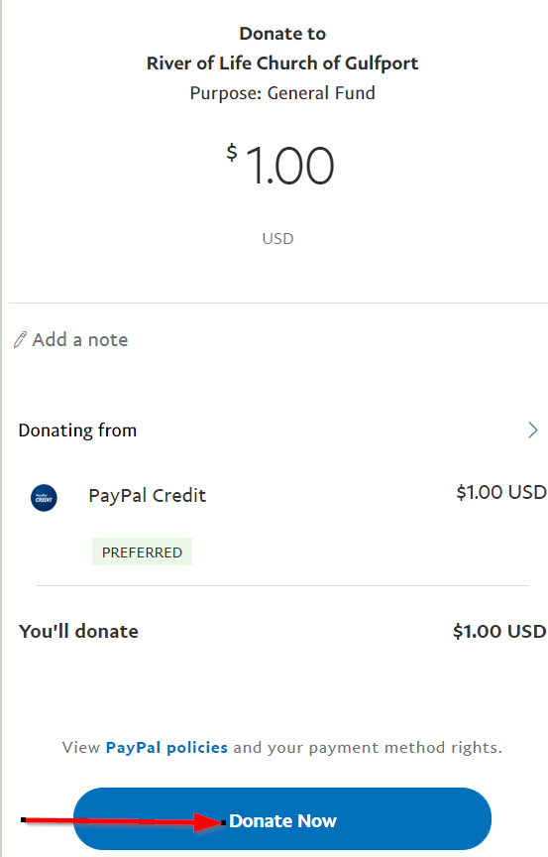
    - Donate with a debit or credit card
      - Fill out form and click “Donate Now” at the bottom
        - 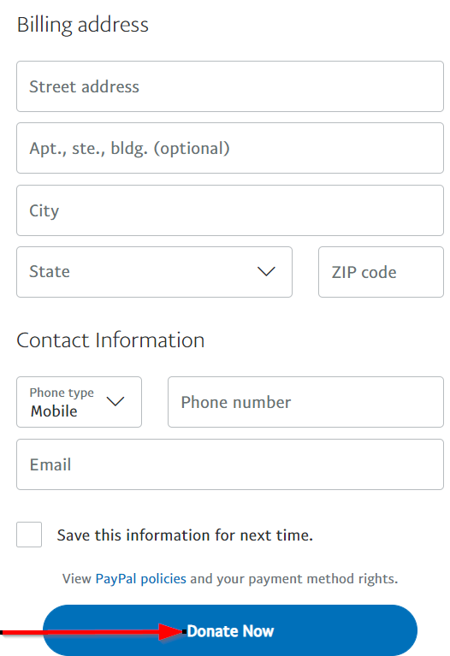
        - Follow the directions

